Name: Poorab Gangwani

Section:2B

Enrollment #:CS191092

**LAB # 8**

**Uncontrolled Full-Wave Bridge Rectifier**

**Lab Objectives:**

* To study the characteristics and operation of full-wave bridge rectifiers
* To study the effect of smoothing capacitors on the output of rectifiers.
* To find out ripple factor of full-wave bridge rectifier

**Apparatus Required:**

* Function Generator
* Diodes
* Capacitor
* Resistors
* Oscilloscope
* Connecting wires
* Bread Board

**PRE-LAB**

**Full-Wave Bridge Rectifier:**

A bridge rectifier makes use of four diodes in a bridge arrangement to achieve full-wave rectification. This is a widely used configuration. Like the half wave circuit, a full wave rectifier circuit produces an output voltage or current which is purely DC or has some specified DC component. Full wave rectifiers have some fundamental advantages over their half wave rectifier counterparts. Assuming a zero voltage drop across a forward-biased diode, the output voltage will have the same peak value as the input voltage.

Average output voltage of a bridge rectifier will be

$V_{AVG}= \frac{{2xV}_{P}}{π}$ eq. 8.1

Since the half-wave signal at the output voltage is repeated after every half cycle of the input voltage, the time period of the output voltage waveform becomes half of that of the input voltage and the frequency of the output voltage becomes twice of that of the input voltage. The average (DC) output voltage is higher than for half wave, the output of the full wave rectifier has much less ripple than that of the half wave rectifier producing a smoother output waveform.

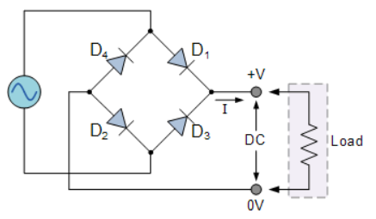

*Fig 8.1: Full-wave bridge rectifier*

During the positive half-cycle of the input voltage, only diodes D1 and D2 will be forward-biased allowing the current to flow as shown in Fig. 8.2. While D3 and D4 will be reverse-biased.

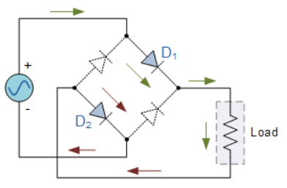

*Fig 8.2: Positive half cycle of bridge rectifier*

During the negative half cycle of the input voltage, only diodes D3 and D4 will be forward-biased, again allowing the current to flow from the same point as shown in Fig. 8.3. Therefore a positive voltage drop across the load resistor will appear during both the half-cycles of the input voltage.

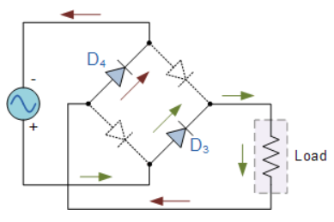

*Fig. 8.3: Negative half cycle of bridge rectifier*

**IN-LAB**

**LAB TASK 1:**

1. Develop the circuit of **fig. 8.1** on breadboard.
2. Supply Sine wave signal from function generator having amplitude **20Vp-p** and frequency **50 Hz** at the input of circuit.
3. Connect the oscilloscope across the load resistor (R=5.7k) and record Vrpp and Vavg in **table 8.1**
4. Now connect capacitor one by one of different values parallel with the load resistor and fill up **table 8.1.**
5. Calculate the ripple factor.

|  |  |  |  |
| --- | --- | --- | --- |
| **Capacitor**  **(µF)** | **Peak to Peak**  **Ripple**  **Voltage**  **Vr(pp)** | **DC average Voltage**  **(Vavg)** | **Ripple Factor**  **(r)** |
| Without Capacitor | **0.091** | **0.057** | **1.596** |
| 10 | **2.112** | **1.344** | **1.570** |
| 33 | **0.778** | **0.495** | **1.571** |
| 47 | **0.556** | **0.353** | **1.575** |
| 100 | **0.263** | **0.167** | **1.574** |

*Table 8.1: lab task 1*

**Conclusion:**

**__________________________________________________________________**

**__________________________________________________________________**

**__________________________________________________________________**

Name: Poorab Gangwani

Enrollment #: CS191092

**POST-LAB ASSIGNMENT # 8**

Q.1) what is the conduction period (in degrees) of diode during ‘Full-Wave Rectification’?

360 degrees

Q.2) What are the merits of full-wave bridge rectifier?

Some of it’s merits are that it is much more efficient than a half wave rectifier. It has higher output voltage , higher output power and higher transformer utilization factor.

Q.3) If the ac supply is 60 Hz, what will be the ripple frequency of the full-wave bridge rectifier?

___120hz________________________________________________________________________